Unofficial English Translation

Companion Dog Behaviour Test

“Dog in the City” (National Test, Georgia)

General Provisions
Dogs of all breeds and sizes are accepted. The age of acceptance is set by the National Organization, but cannot be less than 9 months.
Dogs that do not receive 70% of the maximum points in Part A (testing on the training ground) will not be allowed to participate in Part B (testing in urban conditions). At the end of the test, the judge does not announce the result in points, but evaluates it as “passed” or “failed”.
The test is passed if 70% of the maximum points are accumulated in Part A, and the work in Part B is considered satisfactory by the judge. However, the judge may, at the request of the organizers, arrange places for the award ceremony.
Retaking the test in case of failure is not tied to any deadlines, but is carried out only once within one event (for example, a two-day event). The result of each test is included in the test report, regardless of the success of the test.
There is no test to determine the attitude to shooting during the "Dog in the City" tests.

Basic requirements
Dog condition
- Self-confidence
- Cheerful, motivated work
- Concentration / attention
- Team harmony
Technical correctness
- Position
- Execution
When evaluating each exercise, it is necessary to carefully observe the dog's behavior from the moment of taking the starting position until the end of the exercise.

Teams
If the dog does not complete the exercise by the third command, the corresponding exercise is considered failed and is terminated. When calling, instead of the command, the dog's name may be used when the handler calls the dog. The dog's name together with any command is considered an additional command.
Dog's reaction to the command
The dog must perform the exercise happily at the owner's command. Any signs of fear or stress will reduce the score.
Additional commands
If the dog does not complete the exercise by the second additional command (one main command, two additional), the corresponding exercise is scored 0 points. If the dog does not complete part of the exercise after the second additional command, the exercise is scored as "insufficient" as possible.
1st additional command – evaluation for the exercise part “satisfactory” 2nd additional command – evaluation for the exercise part “insufficient”
For example, 5 points for the exercise part:
1st additional command – score “satisfactory” out of 5 points = minus 1.5 points 2nd additional command – score “insufficient” out of 5 points = minus 2.5 points If the dog completes the exercise. Without the command, the exercise part is evaluated as “insufficient”.

Definition of exercises and their evaluation

  - Walking on a leash 15 points
  - Movement without a leash 15 points
  - Sitting from movement 10 points
  - Lying down from movement 10 points
  - Lying down while distracted 10 points

Total 60 points

Report
Before the test, the handler and the dog introduce themselves to the judge and greet him. The dog is on a leash.

Start and end of the exercise
The judge gives permission to start each exercise. Everything else, such as turning, stopping, changing the pace, etc., is done independently, without the judge's instructions.
It is necessary to observe the established time pauses of about 3 seconds. For example, in the following cases: when performing the frontal position - moving to the final position, praise the dog and start a new exercise. If the handler forgets to perform an exercise, the judge asks him to demonstrate the missed exercise. This does not lead to a reduction in points. Missing part of the exercise will affect your assessment.

Performing the basic position
Each exercise begins and ends with the basic position. The initial basic position can only be taken once before each exercise by moving forward (for example, the dog sat incorrectly in the last basic position. Take one step forward and correct the basic position.). In the main position, the dog should sit straight, be attentive to the handler, sit next to the handler, at the level of the left knee. In the main position, the handler should not stand in the "legs apart" position and both hands should be freely lowered along the body.

Development
The development of the exercise is completed from the basic position of the exercises "sit from movement" and "lie down on call". The development of the exercise should be no less than 10 and no more than 15 steps before the command to perform the exercise is given.

Retrieving the dog
In exercises in which the dog must be retrieved by the handler, the handler may approach the dog from the front or from the back.

Call/ Frontal Sit/ Move to Final Position
When calling the dog, you can use the dog's name instead of the call command. The dog's name is considered an additional command in combination with another command. The dog should approach the handler in a playful, purposeful and straight line and sit right in front of the handler. On command to take the main position, the dog should immediately move to the final position. The final position can be taken next to or in front of the handler.

Praise
Praise is allowed after each completed exercise only in the main position. If this position is the starting base position for the next exercise, then you should pause for about 3 seconds after the praise.

Position errors
For all technical exercises (sit, down), regardless of subsequent errors, if there is a position error, the score for the entire exercise will be reduced by 50% (for example, the dog remained on the command to stand).

Part A.
Execution
The handler approaches the judge with the dog on the leash, puts the dog on the leash and reports to the judge. After the judge’s permission, the handler, together with the dog, goes to the starting point and takes the main position. The handler takes the initial main position when the handler of the other dog takes the main position in the attention exercise. At the judge’s command, the handler begins the exercise.

1. Walking on the leash
From a straight, calm basic position, on the command to move to the side, the dog follows its handler attentively, cheerfully, evenly and quickly. The dog's shoulders should always remain at the level of the handler's left knee, and when stopping, the dog should sit independently, quickly and evenly.
At the beginning of the exercise, the handler walks straight with his dog for 50 steps, without stopping. After turning and, if necessary, the next 10-15 steps, on the command to move nearby, the handler should perform a jog and a slow movement (every 10-15 steps). The jog or slow movement should be clearly distinguished from the normal walk. The transition from jog to slow movement should be carried out without transitional steps.
The initial main position is also the location of the final main position.
When working in a group, the handler and his dog should go around one person on the left, the other on the right, and stop once in the group.
The handler demonstrates a turn on the left shoulder. The dog may either circle the handler to the right or remain on the leash at the level of the left knee. The execution of the turn must be consistent within the same test or competition.
The walk is performed according to the diagram below.
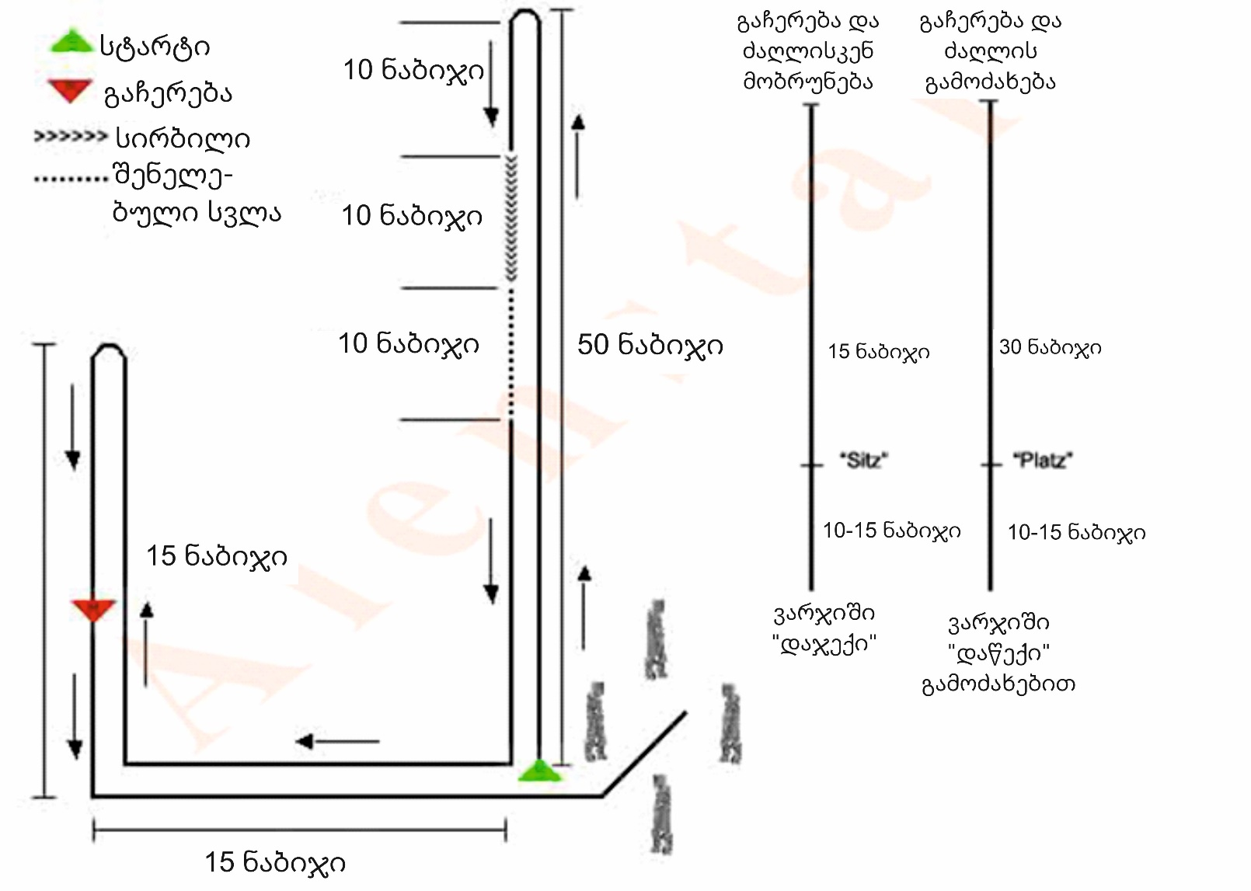
After the second turn, a stop is shown. In this case, the dog must immediately sit down without command. The group progress is shown as follows. In the group, the handler and his dog must pass one person to the left and one person to the right (e.g., a figure eight) and stop at least once next to the person. The judge may request a repetition of the performance. On the judge’s instruction, the handler and his dog leave the group and assume the final main position. The dog may only be praised after the group has reached the final base position.

2. Movement without a harness
When moving without a harness, the train walks 50 steps straight, after 10-15 steps after turning, starts running, demonstrates 10-15 steps, then switches to a slow walk without passing steps, walks again at a normal pace for 10-15 steps. The exercise ends with a transition to the final basic position.
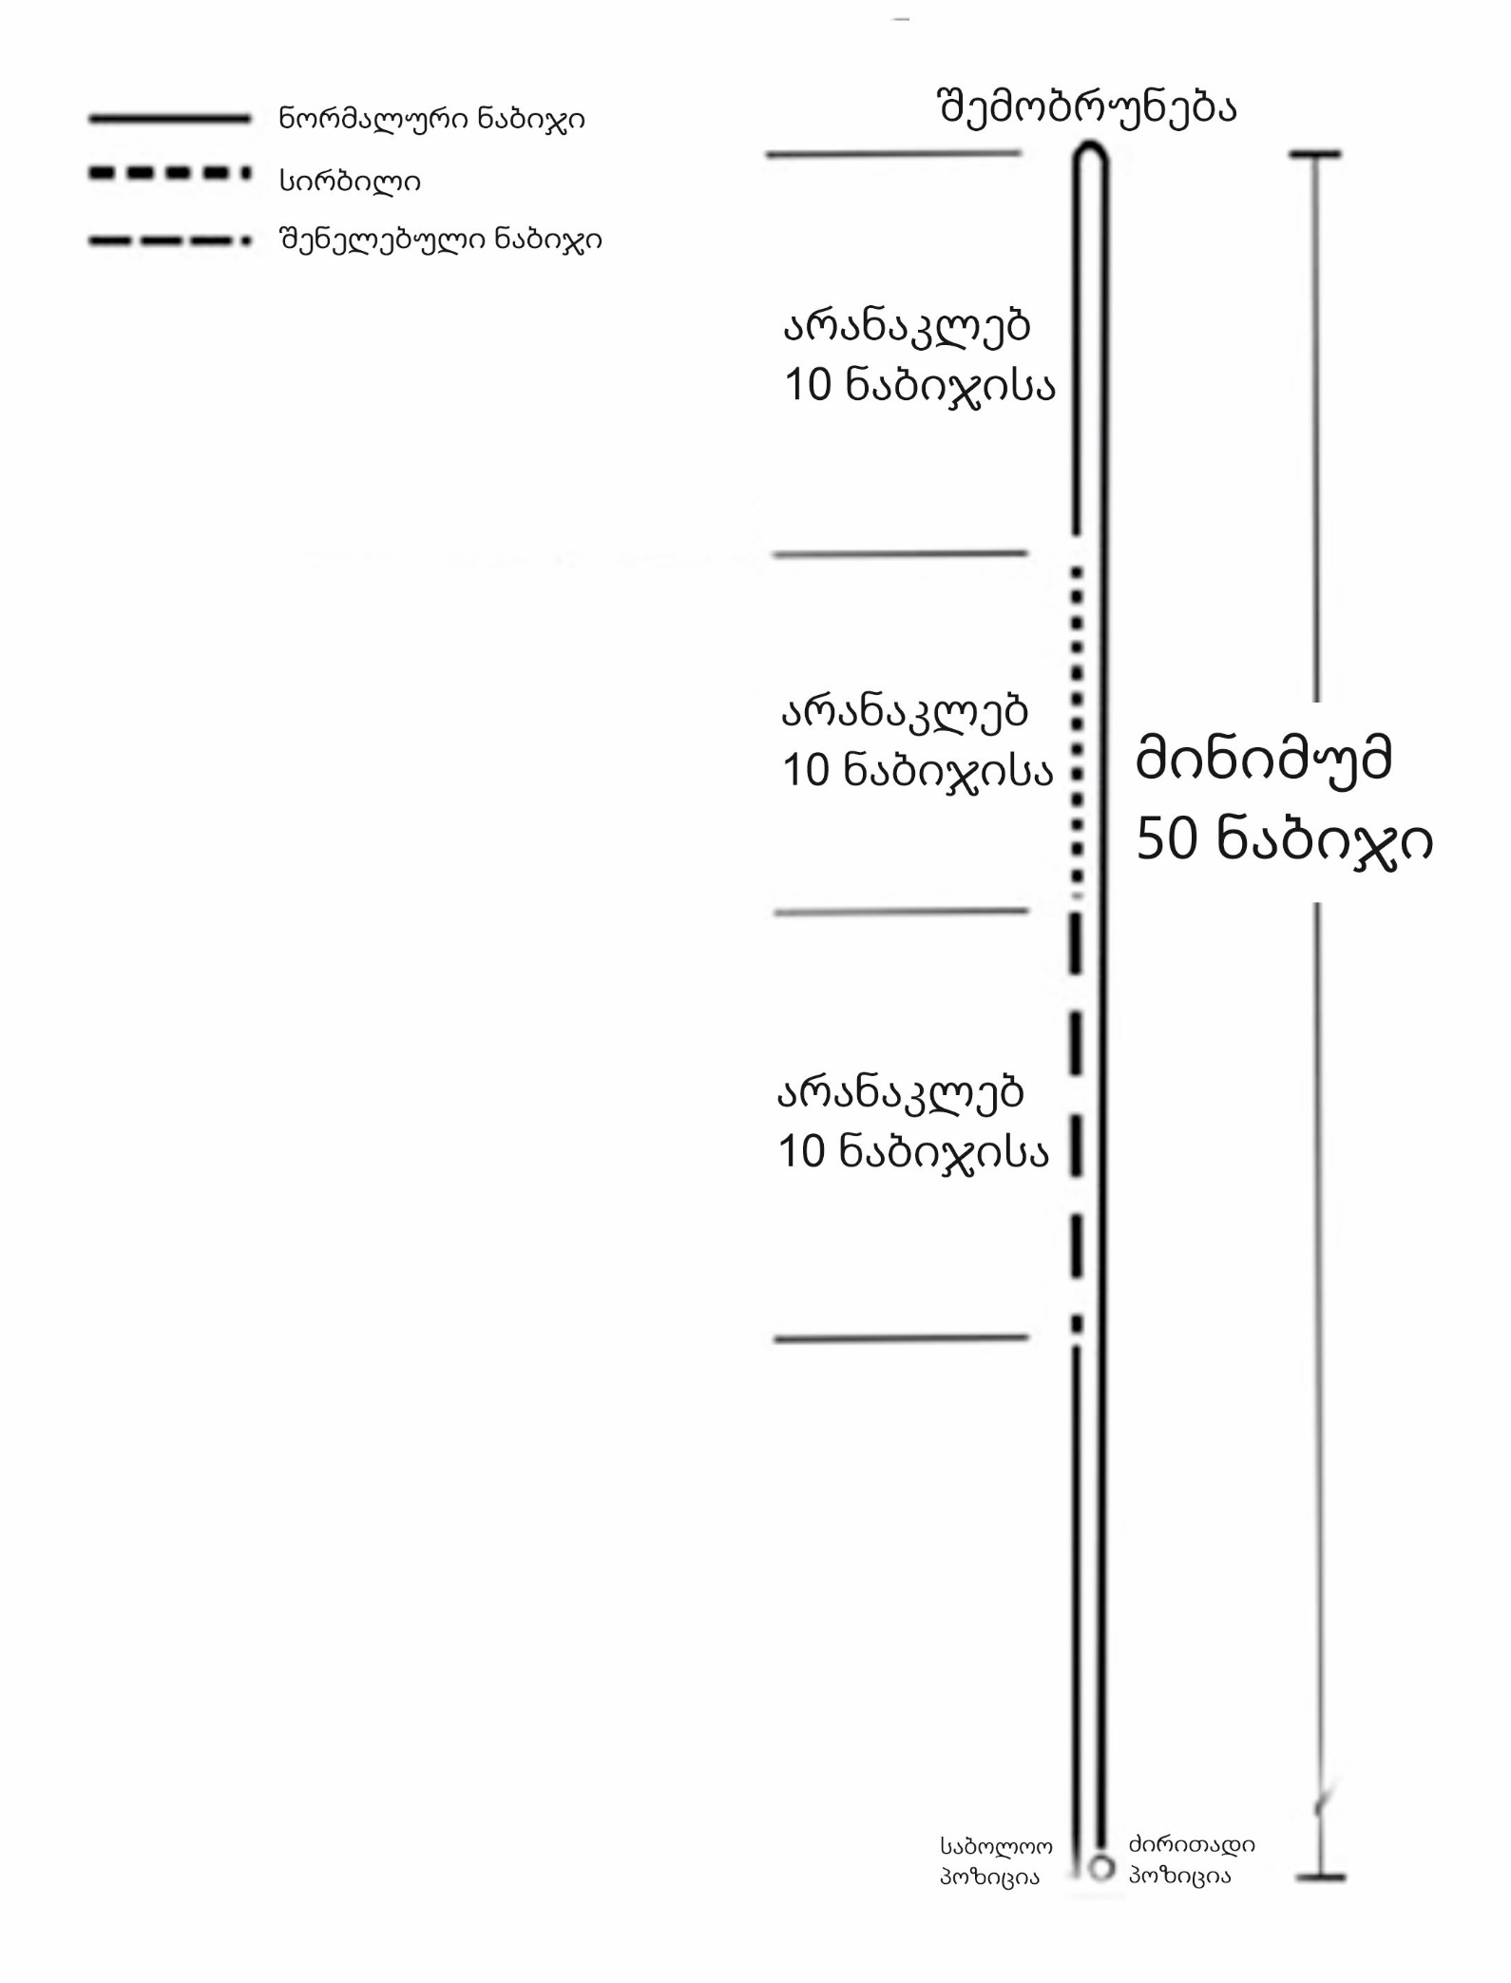
When driving without a harness, you will no longer need to re-enter the group and turn right/turn/stop!

Scoring criteria
Running forward, turning sideways, falling behind, slow or hesitant landing, additional commands, body support, errors in the main position, inattention, lack of enthusiasm for the work/motivation, as well as a change in the dog's character or stubbornness will lead to a reduction in the score.

3. Sitting from the move
Part 1: Initial basic position, development of the exercise, execution of the sit command - accounts for 50% of the total points for the exercise.
Part 2: Moving away from the dog and approaching the handler, final basic position - accounts for 50%.
After 10-15 steps from the start of the exercise, the handler stops, gives the dog the sit command and then moves away from the dog. It is also permissible to give the command to sit while moving, without stopping.
The dog must sit immediately and accurately, in the direction of movement. The dog must sit quickly, without changing the movement of the handler (e.g. slowing down or pausing) or looking back. The dog must sit quietly and carefully watching the handler. The handler moves 15 steps away from the dog. At the judge’s command, the handler returns to his dog.
Scoring criteria
Slow sitting Restless and inattentive behavior during sitting, among other faults, leads to a low score. If the dog stands up or lies down, an additional 5 points are deducted from the exercise.

4. Down on call
Part 1: Initial basic position, development of the exercise, execution of the command constitute 50% of the total points of the exercise.
Part 2: Response, Front Landing, Final Base Position - accounts for 50% of the total points for the exercise..
After 10-15 steps of the exercise, the handler stops, gives the dog the command to lie down and then moves away from the dog (a 3-second time interval is required). It is also permissible to give the command while moving, without stopping.
On the command to lie down, the dog must lie down immediately and exactly in the direction of the movement. When performed without stopping, the dog must lie down immediately, without changing the hand movement (e.g. slow down or stop) or looking back.
The handler moves away for at least 30 steps and then returns to his dog. The dog must remain calm and attentive until called, and the dog is called by the judge with the recall command or by name. The dog must approach the handler in a playful, purposeful and precise manner and sit exactly in front of the handler. On command to take the main position, the dog must move exactly to the final main position.
Scoring criteria
Slow lying down, restless and careless behavior while lying down, unfocused approach of the dog, assistance from the handler or a “legs apart” position, among other violations, will result in a low score. If the dog stands up or sits, the overall exercise will be scored with 50% of the points of the entire exercise. For a dog that is not ready for the second additional command, the exercise will be scored as “insufficient” (0 points). In this case, the dog returns and can continue the test.

5. Down with distraction
Down with distraction is an exercise performed with the participation of a second dog. In this exercise, the dog is called from the main position to a place indicated by the judge on command. The handler, at the judge’s command, moves away from the dog at least 30 steps and stands in the dog’s field of vision, with his back to it
While the second dog is working, the dog must lie quietly, without the handler.
*For safety reasons, the dog must be attached to a 10-meter leash behind its head on a strong support and the leash must not be stretched.
Evaluation criteria
Incorrect basic position, restless behavior, assistance from the handler, the dog getting up too early, the dog standing or sitting down, leaving the lying position will result in a corresponding reduction in points.
Leaving the mounting point more than 3 meters away will result in a reduction in points. If the dog moves towards the train approaching it, 3 points may be deducted.
If the dog leaves the lying area for more than 3 meters, it is permissible to perform the next exercise with a minus 50% mark. A partial mark is possible if the dog lies down before the other dog performs the exercise and performs the side walk exercise without a leash.

Part B. Tests in urban conditions
All the following exercises are performed outside the training area, in a suitable location in a built-up area. The judge, together with the test leader, decides where and how the test will be conducted (streets, roads or squares). Public transport cannot be used as part of this test.
Due to its specific nature, this part of the test takes a considerable amount of time to complete. The judge’s requirements should not be superficial due to the large number of dogs.
No points are awarded for individual exercises. The judge's overall impression of the dog's behavior in the city is the determining factor.
The exercises described below are guidelines and may be modified by the judge based on his assessment of the actual conditions. The judge has the right to request a repetition of the exercise or perform it in a different version if he has doubts when evaluating the dog.

Passing the tests
(The exercises presented are minimal and may be expanded at the discretion of the organizing country)

1. Meeting a group of people
At the judge's command, the handler begins to move with his dog, which is on a leash, along the street. The judge follows the handler for a certain distance. The dog should move on a loose leash to the left of the handler so that its shoulders are at the level of the handler's knees. The dog should not react to pedestrians or cars. People must pass by the owner and the dog. The dog must behave neutrally according to the standard set out in the FCI IGP Rules - 2019 page 23 of 64. Then, the handler and the dog must pass through a group of people (minimum 6 people), one of the people speaking and holding the handler's hand. The dog must sit or lie down at the owner's command and must behave calmly during the short conversation.

2. Meeting a cyclist
The handler leads the dog along the road on a leash. The cyclist catches up and overtakes them from behind, while ringing the bell. The cyclist goes further, turns a long way from the handler and the dog, and then comes towards them. At the same time, the bell rings again. The cyclist must pass so that the dog is between the handler and the cyclist. The dog must behave calmly.

3. Meeting with a car
The owner walks with the dog on a leash to several cars. At the same time, one car starts moving, a person in the other car slams the door. The train and the dog walk further, the car stops nearby, the driver rolls down the window and asks the owner something. In this case, the dog should sit or lie down at the owner's command. The dog should behave calmly and neutrally towards the cars, the noise of the traffic, and the person in the car who is talking to the train.

4. Meeting with a runner or a person in wheelchairs
The owner walks with his dog along the street. At least two runners overtake them without slowing down. When the runners move apart, new runners appear, who run with the dog towards the train, running alongside without slowing down. The dog does not have to walk right at the foot of the train, but it should not react actively to the runners or move towards the foot of the train from runners who overtake them or run towards them. It is allowed for the dog to sit or lie down by the trainer while the runner passes. Instead of runners, there may be people on rollers who will pass the train and the dog and then go towards them again.

5. Meeting other dogs
When meeting another dog that is walking or overtaking its trainer, the test dog must behave neutrally. The handler can repeat the command “side” or put his dog down or down when meeting.
Behavior of a dog left alone for a while on a leash and when meeting animals
At the judge’s command, the owner and the dog start moving along a fairly busy street. After a short distance, the handler stops in the direction of the judge and the dog, tied to something (fence, tree, pole), enters a store or entrance. The dog can stand, sit or lie down. In the absence of the handler, another person walks with another dog about 5 steps away from the dog on a leash (the additional dog should not be aggressive). The dog under test should behave calmly in the absence of the owner and should not pull towards the other dog. (At this time, hold the leash of the other dog firmly, bark at it for a long time). At the judge’s command, the owner The dog is led.
6. Behavior with a leash
The owner puts a leash on the dog, removes the leash and allows it to run freely next to or around the territory. At the judge's command, the owner calls the dog to him and fastens the leash (if the dog has not gone far and has moved next to the train, simply fasten the leash).
The test "Behavior with a leash" is considered successfully passed if the dog, while moving freely, did not try to remove the leash.

Note:
The judge has the discretion to decide whether to conduct separate exercises with each dog in different places provided for this, or whether all competitors perform only a few exercises in one place and then look for another place to continue the tests.

